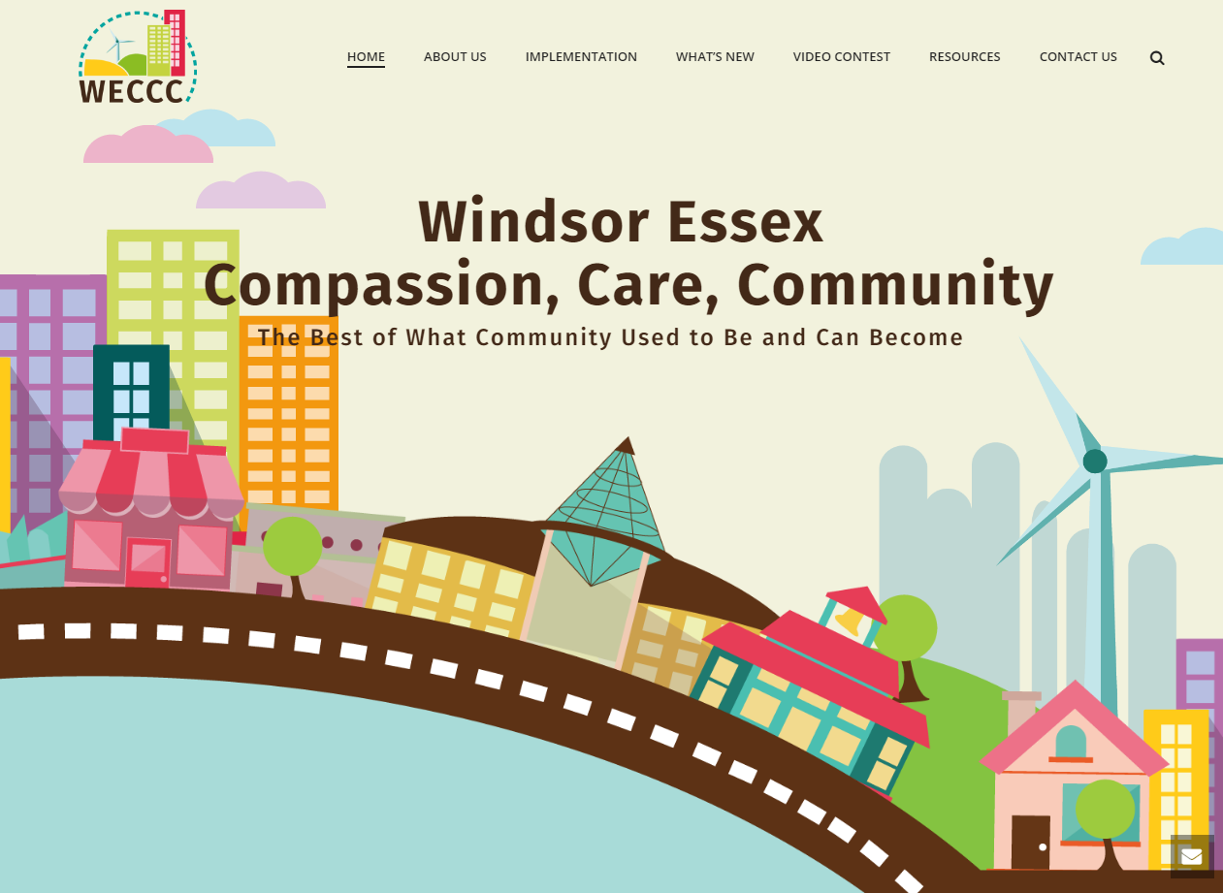

WECCC 2019 Annual Report Series
Community Development And Partner Engagement

Highlights
The Windsor Essex Compassion Care Community (WECCC) has a strong community development and capacity-building focus. WECCC efforts in 2019 included working with local champions in 4 new geographies to spread Compassion hubs more widely throughout Windsor and Essex county; partnering with 65 community organizations who are directly supporting the WECCC movement at a number of different levels and continuing to engage new partners; hosting neighbourhood connections, events and meet-ups to encourage new connections; and supporting a variety of communications events and channels to grow public awareness.

A. Creation of New Compassion Hubs
In 2019, WECCC launched a new satellite hub in West Windsor (Assumption Cares) and is working with local leaders to establish new hubs in Amherstburg (Compassion Amherstburg) and Tecumseh (Compassion Tecumseh). We also continue to support the Kingsville hub (Kingsville Community Centre). Geographically-based Compassion Hubs offer a wide range of WECCC services, public wellness and education activities, and engage local partners to co-design their own local solutions and create new opportunities. Our vision is for each township in Essex county and municipal wards in Windsor to have their own compassion hub to build collective ownership and engage a wide range of local partners and co-design solutions based on the needs and aspirations of their local neighbourhoods. Eventually, once they grow in capacity and mature, each Compassion Hub should have their own Program Lead and team of volunteers and dedicated space where the full range of WECCC education, screening, and intervention services can be offered alongside a range of community interest and wellness programs. Backbone support in the form of training and mentorship, data management and applied research, and basic communications is available through the WECCC PMO team at the Hospice of Windsor Essex.

Details on each hub are as follows:

1. Assumption Cares
Sponsor - Our Lady of Assumption Church, Windsor Ontario
Location: Our Lady of Assumption Church, Windsor Ontario
Service Area Priority: West Windsor – all ages, denominations
Activities to Date:
- Hiring of a Coordinator
- Volunteers have been recruited and will continue to be recruited.
- Volunteer Training Preliminary training completed. Training to continue to include Caring Conversations and Sharing My Journey training.
New community interest and wellness programs:
- Needs assessment completed to determine local priorities for new wellness and interest program and activities
- Currently the following free weekly activities are now available: Cards and Games, Walk and Talk, Conversation English Circle, Health Screening, Monday Evening Meal, Cooking Club, Exercise, Mindfulness Meditation, Free Produce Distribution, Living With Grief, Group Education and Support: The Importance of Being Connected has been provided and will be provided at least quarterly; Advanced Care Planning has been provided and will be provided quarterly
- Community Map: Windsor Resource Document to be further developed.
- Will determine gaps in service when analyzing the Neighbours Survey – what activities individuals would like to engage in and what is missing.
Communicating with the Community:
- WECCC is working with Assumption Cares in the development and implementation of their communication plan.
Community Connectors Volunteer Recruitment Status and Training
2020 Priorities/ Next Steps:
- Volunteer training Caring Conversations/Sharing My Journey in the New Year
  - Neighbours Survey completion of individuals attending Hub Activities
  - Identification of individuals at risk
  - Process Development – Sharing My Journey for support of individuals at risk
- Continued Volunteer Recruitment
- Community engagement to further enhance activities provided in the hub based on activities of interest for individuals in the community

2. Compassion Amherstburg
Sponsor - TBD - Community Coalition emerging
Location – TBD - co-location with the new municipal Seniors’ Hub
Service Area Priority: Amherstburg and surrounding area – Harrow, LaSalle
Activities to Date:
- Community Agency Recruitment
  - Amherstburg Community Church
  - Amherstburg Community Services
  - ALSO
  - Lighthouse Church
  - St Andrew’s Presbyterian Church
  - Amherstburg Family Health Team
- Volunteer Recruitment underway
- Volunteer Training beginning stages
New community interest and wellness programs:
- Amherstburg and Area Social Resources Document Creation
  - Program Development and Social Hub Activities to be documented, further developed and shared among the community partners. Referral process to be developed
- Engagement of Social and Health Service agencies in the area to further enhance the resource document and to provide information to all agencies involved to further enhance referral to the resources
- Group Education and Support
  - IBC has been provided in 4 of the above mentioned agencies, IBC to be offered quarterly in the Amherstburg and surrounding area
  - Advanced Care Planning has been provided in 2 of the above mentioned agencies and to be provided quarterly in the Amherstburg and surrounding area
- Will determine gaps in service when analyzing the Neighbours Survey – what activities individuals would like to engage in and what is missing. Amherstburg Community Services is interested in leading this
Communicating with the Community
- Robust community communication plan to be developed
2020 Priorities/ Next Steps:
- Volunteer training Caring Conversations/Sharing My Journey being planned for the New Year
  - Neighbours Survey completion of individuals attending Hub Activities
  - Identification of individuals at risk
  - Process Development– Sharing My Journey for support of individuals at risk
- Continued Volunteer Recruitment and training by WECCC and each agency participant
- Community engagement to further enhance activities provided within the agencies based on activities of interest for individuals in the community
- Creation of Amherstburg Coalition – to bring together leaders of the above named agencies to further develop Compassion Amherstburg
- Further outreach to social and support agencies in the Amherstburg area to engage their support and involvement

3. Compassionate Tecumseh
Sponsor – Tecumseh Town Council – Seniors’ Advisory Committee; Home Instead Seniors Care
Location – TBD – suggestion is Tecumseh Sports Plex – Tecumseh is in planning phase for this build. The Sports Plex is meant to be a gathering location for activities for all age groups and will provide a central location to offer all different types of activities that are of interest to the community. In the meantime there are several locations where activities do and can occur including but not limited to Tecumseh arena, Golden Age Club, Atlas Tube Centre, etc
Service Area Priority: Tecumseh and Lakeshore
Activities to Date:
- Presentation to Tecumseh Town Council – WECCC and the effects of loneliness
- Municipal Partnership via Tecumseh Seniors’ Advisory Community
- Community Agency Recruitment
  - WECCC is in the planning phase to contact various organizations that support Tecumseh area to gain support and engage them in WECCC program activities with a goal of gaining momentum
- Identification of a lead volunteer who has a strong personal mission to develop Compassionate Tecumseh
New community interest and wellness programs:
- Local priorities for new wellness and interest programs and activities are being determined. WECCC can assist in identifying gaps in service when analyzing the Neighbours Survey – what activities individuals would like to engage in and what is missing.
- Currently the Tecumseh Golden Age Club provides a gathering place for seniors to engage in games, meals together and offering of educational opportunities. Importance of Being Connected has been provided.
- Community Map: Resource Document to be further developed.
Communicating with the Community
- To be considered in 2020
2020 Priorities/ Next Steps:
- Continued Volunteer Recruitment and training by WECCC and each agency participant
- Community engagement to further enhance activities provided within the agencies based on activities of interest for individuals in the community
- Creation of community coalition – to bring together leaders of supporting agencies to further develop Compassionate Tecumseh

4. Kingsville Community Centre
Sponsor/ Location: Kingsville Community Church
KCC functions as a partnership with 15 other community agencies that offer free social, educational, nutritional and wellness programs each Tuesday and Thursday for those of all ages within the Kingsville and Essex County region. See below for a snap-shot of regular weekly programs. Special events and programs are also offered each month.
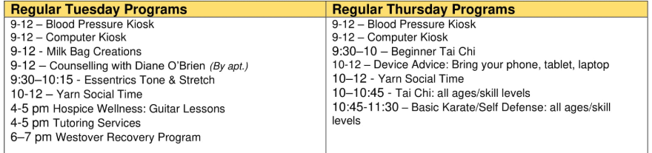

All KCC participants are informed about and encouraged to think of themselves as part of WECCC. Group education workshops (Importance of Being Connected and Advanced Care Planning) and We Care Let’s Talk events are offered. For an overview of the centre, see:
https://www.youtube.com/watch?v=fypYsO9MW0w&feature=youtu.be

There is interest in engaging students assigned to the centre to conduct caring conversations and conduct Neighbours Surveys with individual as a follow-up for those who have completed it previously and for new participant in KCC activities. Education is planned for the New Year.

B. WECCC Community Partnership Agreements
The WECCC movement is entirely partnership based. WECCC works with community partners to embed WECCC tools and processes within existing organizations, and to offer WECCC services and workshops to members within partner locations. We also work at making people more aware of both formal and informal community assets through the creation of neighbourhood maps and resource guides, event schedules and community calendars. As a result, community partners are becoming better connected to each other and to the public in order to open their doors wider so more individuals can benefit from social activities occurring there. By becoming more aware of what is available in their communities, partners can more easily refer individuals to the activities that interest them and to build connection by sharing activities they love to do with others. Bringing this full circle, WECCC also engages the whole of community in developing new opportunities to address the aspirations and needs of groups of individuals.

WECCC is mobilizing a wide range of community partners across all sectors to contribute to collective efforts to build more caring communities and improve population health and quality of life. WECCC supports 5 types of community partnership agreements, including:
Type of Partner | Definition and Criteria
1. Compassion Hub Sponsor | Geographically-based Compassion Hubs offer a wide range of WECCC services, public wellness and education activities, and engage local partners to co-design their own local solutions and create new opportunities. Our vision is for each township or municipal ward to have their own compassion hub to build collective ownership and engage a wide range of local partners.  Criteria: Sponsorship agreement; In-house program Lead and team of volunteers recruited and trained to deliver WECCC processes and tools; Relationship with WECCC PMO for data and backbone support. A sponsor can be a single organization or a coalition of WECCC affiliates.
2. WECCC Affiliate | As above, with the exception that an affiliate organization will operate at a smaller scale than a township or ward geography. For example, WECCC affiliate organizations may serve single target populations; patients or members who are already part of an existing organization; or a smaller geography such as a neighbourhood.
3. Identification and Referral (Compassion is our First Response Network) | Front-line agencies who are in a position to identify individuals who may be falling through the cracks of community care, and connect the person with WECCC for extra help, but do not have the capacity or trained volunteers to offer WECCC tools, services and supports in-house.
4. Public Education Promotion and Outreach | Organizations who have agreed to work with WECCC to offer one-time or recurring WECCC education workshops (loneliness, advanced care planning, etc) for staff, individuals, families at their location
5. Neighbourhood and general support | Organizations who act in other ways to build a more caring community, including growing informal neighbourhood exchanges for residents to share time and talent, creating more opportunities for social participation, and/or sharing information with WECCC for use in creating our community profile and community outcome tracking

Current Partnerships

Compassion Hub Sponsor
Windsor | - The Hospice of Windsor Essex County (Windsor East)  - Assumption Cares - Our Lady of Assumption Church (Windsor West)
Kingsville | - Kingsville Community Centre  - First Lutheran Church
Leamington
Tecumseh & Lakeshore | Under development for 2020  - Tecumseh Town Council, Seniors’ Advisory Council  - Home Instead Seniors Care, Tecumseh  - Lakeshore – Atlas Tube Seniors’ Centre  - Community Support Centre of Essex County  - Belle River Catholic Church  - St. Anne’s Parish  - Tecumseh United Church  - St Mark’s by the Lake  - Tecumseh Golden Age
Amherstburg | - Amherstburg Town Council  - Amherstburg Community Church  - Amherstburg Community Services  - ALSO Amherstburg hub  - Lighthouse Church  - St Andrew’s Presbyterian Church  - Amherstburg Family Health Team
Essex | Under development for 2020  - Harrow Family Health Team  - Essex Community Services  - Essex Library and seniors group
LaSalle
Sarnia-Lambton | Under development for 2020  - Bluewater Health  - Inn of the Good Sheppard  - Lambton Elderly Outreach  - North Lambton Community Health Centre  - St. Joseph’s Hospice Sarnia  - Lambton College

WECCC Affiliates (Agencies or Population Hubs)
Windsor | - WE Trans – service to trans and queers  - Windsor Women Working with Immigrant Women – service to immigrant women  - University of Windsor – student engagement  - St Clair College – student engagement  Under development for 2020  - New Song Church, Feeding Windsor initiative – service to the homeless and people living in poverty  - Assumption University – part of campus ministry, service to students  - Correctional Services; John Howard Society – service to offender groups  - Windsor Essex Community Health Center - Pulmonary Wellness programming  - YMCA
Kingsville
Leamington | Under development for 2020  - Rosewood Erie Glen – service to retirement home residents
Tecumseh & Lakeshore
Amherstburg
Essex
LaSalle
Additional priority target groups under consideration – timing TBD | - Caregivers for people with dementia (Alzheimer Society of Windsor and Essex County)  - At Risk Youth (Community Living Windsor, Family Respite Services, Family Services Windsor Essex)  - Stroke Rehab (Brain Injury Association of Windsor Essex; Alpha 1 Canada; Heart and Stroke Foundation)  - Parkinson’s group  - Newcomers and cultural communities (Multi-Cultural Council; New Canadians Centre of Excellence; ECCCA Evergreen Seniors (Chinese Association); Brazilian Community; Black/African Community; Iraqi Canadian Group; Windsor Jewish Federation and Community Centre; South Asian; Fogolar Furlan Club (Italian Community)  - Faith communities (Windsor Mennonite Fellowship; Our Lady of Mount Carmel; Corpus Christie; Windsor Christian Fellowship)  - Francophones (College Boreal)

Identification and Referral (Compassion is our First Response Network)
Windsor | - Windsor Downtown Mission  - Family Services Windsor Essex  - EMS Vulnerable Persons Program  - LHIN Home Care program  - Canadian Mental Health Association (CMHA)  - Windsor Regional Hospital - Ouellette and Met  - Hotel Dieu Grace Hospital – Prince Rd  - Family Health Teams – Windsor  - Community Health Centres – WECHC and City Centre  - Windsor Essex County Health Unit  - Teen Health Centre  - Crisis Centre  - Libraries of Windsor Essex  - Police Services  - Fire Services  - Meals on Wheels agencies,  - Salvation Army  - St Vincent de Paul  - Paramed
Kingsville
Leamington | - The Hospice of Windsor Essex County (Erie Shores Campus)
Tecumseh & Lakeshore
Amherstburg
Essex | - Family Health Teams – Harrow
LaSalle

Public Education Promotion and Outreach (Workshop location)
Windsor | - CARP  - Unifor 444 Retirees  - Canterbury Elder College  - LSDG: Ken Gerard Seniors Apartments  - LAF: Ashgrove Manor, 140 Bridge Ave. – 208 units  - LAF: Campbell Cottages, 1124-1224 Campbell Ave. – 120  - LAF: Cencourse Project Inc., 30 Tuscarora – 294 units  - LAF: Cherniak Manor, 120 Oak – 117 units  - LAF: Dieppe Towers, 120 Caron – 151 units  - LAF: Fontainbleau Towers, 2455 Rivard – 386 units  - LAF: Heimathof, 5060 Wyandotte E. – 50 units  - LAF: IL Peretz, 1653 Ouellette – 71 units  - LAF: Ouellette Manor, 920 Ouellette – 400 units  - LAF: Raymond Desmarais, 255 Riverside – 300 units  - LAF: Reaume Manor, 605 Mill St. – 129 units  - LAF: Riggs Manor, 4365 Wyandotte E. – 50 units  - LAF: W5, 1368 Ouellette Ave. – 16-20 Seniors  - LAF: Westgate, 3294 Sandwich St. – 62 units  - CHAPs: 2455 Rivard  - CHAPs: 140 Bridge  - Chartwell Homes - Windsor  - Cardinal Homes  - Grachanica Non-Profit Housing Corporation  - Lifetimes on Riverside  South Windsor  - Greenwood Church, South Windsor  - South Windsor Seniors Association  - Windsor Library Seniors club
Kingsville | - Chartwell Homes - Kingsville  - First Lutheran Kingsville
Leamington | - Chartwell Homes - Leamington  - LAF: The Cedars Apartments, 165 Talbot Street East, Leamington  - Leamington Lodge  - Seniors Alternative Residence  - Sun Parlor Homes  - Leamington United Mennonite Homes and Apartments  - Half Century Club  - Meadow Brook Church
Tecumseh & Lakeshore | - Chartwell Homes - Lakeshore  - Home Instead – Former Clients Group  - Parkwood Gospel Temple
Amherstburg | - LAF: 340 Victoria Street South, Amherstburg – 40 Units  - LAF: 346 Victoria Street South, Amherstburg – 27 Units  - LAF: Wesview, 160 Pickering, Amherstburg – 50 units
Essex | - LAF: Maplewood Apartments, 109 Brien, Essex – 68 units  - LAF: Maplewood Apartments, 111 Brien, Essex – 69 units  - Essex Retirees  - St Andrew’s Anglican Church
LaSalle | - Chartwell Homes – LaSalle  - St. Paul’s RC Church Lasalle ON

Neighbourhood and general support
Windsor | - Downtown Windsor Community Collaborative  - Ford City  - Life After Fifty

C. Neighbourhood connections, events and meet-ups
The WECCC team spoke with multiple groups throughout the year to raise awareness, build partnerships, and to encourage front line workers to connect WECCC to individuals that would benefit from its resources/services. Moving forward, WECCC is interested in developing more opportunities for neighbours to informally exchange help and experiences with each other on their own terms, opportunities for people receiving help to identify ways they can help others, and for corporate philanthropy.

March 5 – Faith Mennonite Church – Intro to WECCC 25 people
People from Faith Mennonite Church, along with several other leaders in Leamington’s faith community gathered to learn what Windsor Essex Compassion Care Community is and how others could join the movement. There was interest in learning more about the movement, in particular how it could support homeless youth or at risk of homelessness in the area. Two church groups requested a loneliness intervention workshop so that they could learn how to better support others while improving their own quality of life.

March 25-29 – Tecumseh Mall - Compassion Week at Tecumseh Mall
This event took place inside of a store space near the food court in Tecumseh Mall. Students, volunteers, employees and partner agencies supported this week long event with booths, greeting people at the entrance and by helping patrons of the mall fill out quality of life surveys. Over 100 surveys were filled out during the week and dozens more people stopped by the store space to gain insight about our movement. Tim Hortons and a local bakery provided snacks meanwhile WECCC, with the support of Super Store, provided bottles of water for guests to enjoy. 5 mall employees were recognized for their compassion and presented with a Compassion Award.

April – Health Aging Expo – Leamington Half Century Club – Table provided with information about WECCC and the Importance of Being Connected.

May – Stroke Recovery
WECCC overview provided along with the Importance of Being Connected to 10 Stroke survivors and supports. Additionally the lead for this group has become a WECCC volunteer.

May – Prostrate Support Group
13 individual attended an information session on WECCC and “The Importance of Being Connected”

May 28 - Parkinson Presentation - 7025 Enterprise Way – 7:30pm
“The importance of being connected” education event was held with the Parkinson’s group. This was attended by 16 people.

July 9-11, 2019 – Online/Tecumseh Mall - Give65 Campaign
WECCC participated in 65 hours of online giving during the Home Instead Senor Care Foundation of Canada’s Give65 event. WECCC set up a booth at Tecumseh Mall to raise awareness about the brand, for public promotion and to gain interest from potential volunteers. This online crowdfunding event provided the opportunity for WECCC to raise $5000 and earn$5000 in match funding to support WECCC operations. Our Give65 page can be found at https://www.give65.ca/projects/windsorcompassioncarecommunity.

WECCC presence in malls is proving to be a good way to engage members of the public who might need extra help or are interested in volunteering who would otherwise not hear about WECCC:
- Four surveys were completed and our WECCC summer students/communications team had the opportunity to engage in conversation with 7 individuals who shared stories about their quality of life. Many others took one of our brochures and kindly accepted the idea that they might call us in the future for the extra help they need.
- Several people stopped by to fill out a volunteer form, and were excited about our movement and the possibility of working with us.
- Many people who stopped by our booth said that they were not vulnerable or in need of our services but they knew someone who could benefit.

July 18, 2019 – Kingsville – Kingsville Community Centre Coffee House
Coffee and conversation attracted 49 people to the community centre. The event included refreshments, music and a WECCC booth to raise awareness about our movement and encourage visitors of the centre to fill out surveys.

August 8, 2019 – Windsor – Canadian Blood Services
You’re Somebody’s Type was the slogan for this event which aimed to raise awareness about WECCC meanwhile encouraging people to give blood. The WECCC booth attracted visitors of the Canadian Blood Services to learn more about our movement and how they can improve quality of life for themselves and those around them. Booth occupation was from 11 am - 7 pm.

Sept 3 - 2455 Rivard - Apartment Building
A general over of the project was provided with details of why it is important to be connected in the community. It was also stressed that seniors can be protected and connected with the support of WECCC and Windsor Police Service. This event was attended by 40 people.

Sept 12 – 920 Ouellette Apartment Building
Protected and connected was the theme of this presentation where people were given an overview of WECCC, insight on how to avoid loneliness, and Windsor Police Service followed up with protection. Approximately 20 people attended the presentation.

September 24 Life Times - - 3387 Riverside - 2:30pm
WECCC teamed up with Windsor Police Service during their elder abuse prevention campaign. Prior to a presentation by police, WECCC presented to an audience of around 16 seniors about our movement and how WECCC is working to eliminate loneliness and isolation. The seniors were very interested. They asked questions and the staff asked for and was provided with contact information for future support, presentations or workshops.

October 7 – How a Compassionate Community Can Help with Social Isolation – W5
As a kick-off to Mental Health Awareness week, WECCC was invited to present at a lunch and learn about how a the Windsor Essex Compassion Care movement can help reduce social isolation. The harms of loneliness and social isolation was discussed and how lives can improve with better connection to others and the community.

October 22, 2019 – Windsor – WECCC Compassion Celebration
Over 60 guests attended this event to celebrate our members’ accomplishments and acknowledge the movement and its efforts. Guests participated in activities to help determine what issues members would like to resolve and how partners can work together as a Compassionate Community to best serve the needs of members. Eight surveys were completed. 8 people were recognized for their compassion and presented with a Compassion Award.

November, 2019 - CARP (Canadian Association of Retired Persons)
Presentation provided to Windsor Essex CARP Annual General Meeting on “The Importance of Being Connected”. Additionally information on this topic was provided for CARP members at 3 locations across Windsor Essex in spring of 2019.

November 2019 - New Voices
This is a support group for individuals who have lived with laryngeal cancer. 12 individuals, survivors, along with supports and a Speech Language Pathologist attended an education session on the background of WECCC and “The Importance of Being Connected”.

November 21, 2019 – Windsor - Life After Fifty Seniors Active Living Fair
A table at this fair provides the opportunity to inform seniors about our project and our programs that aim to support them as they age.

Essex and Tecumseh Seniors groups - group education sessions on the topic of “The Importance of Being Connected” and information tables provided at various events.

D. Communications Highlights

The Windsor-Essex Compassion Care Community (WECCC) has been raising awareness, gaining support from leaders in its communities, and informing the public about the movement since 2015. Within three years, the project has met its goal to inform 10,000 people about WECCC and encourage them to join the movement.

MEDIA COVERAGE
Media coverage for the Windsor-Essex Compassion Care Community has been reflective of the efforts put forth by the program to support its goals to share information, encourage participation in events and to promote volunteerism with its programs. The dates and links of media coverage are as follows:

- Health News Media: December 21, 2018 “Compassion Care Community Helps the Vulnerable”. https://www.healthnewsmedia.ca/tag/windsor-essex/

- Ourwindsor.ca: March 20, 2019 “Tecumseh Mall Hosting Compassion Care Community Week”. https://www.ourwindsor.ca/whatson-story/9231154-tecumseh-mall-hosting-compassion-care-community-week/

- The Morning Drive (AM800 News): July 23, 2019 “Windsor Essex Compassion Care Community”. https://omny.fm/shows/am-800-cklw/morning-drive-windsor-essex-compassion-care-commun#description

- The Peterborough Examiner: July 29, 2019 “Windsor Essex Compassion Care Community Blood Drive August 8”. https://www.thepeterboroughexaminer.com/community-story/9524564-windsor-essex-compassion-care-community-blood-drive-august-8/

- The Shoreline: September 27, 2019 “WECCC Believes In Harnessing the Power of Community”. (found on hardcopy only)

- Downtown Mission: November 13, 2019 – December 25, 2019 “We Care Let’s Talk”. https://www.downtownmission.com/event/we-care-lets-chat/all/

NEWS ARTICLE SUMMARIES

- Health News Media: he Windsor-Essex Compassion Care Community (WECCC) is a non-profit coalition that brings together over 300 champions and 100 agencies to provide a fully effective community care system for elderly and vulnerable citizens in Windsor-Essex County. Comprised of associations from education, health care, social services, municipal, cultural and faith communities, business, non-profit, volunteer and informal sectors, currently, the WECCC serves about 750 clients. The formation of WECCC now brings together compassionate care to the elderly, people living with a disability, and others who live in isolation across Windsor and the seven municipalities of Essex County. Citizens who fall into these groups may represent as much as 25% of the community.

- Ourwindsor.ca: Windsor-Essex Compassion Care Community and Tecumseh Mall will be hosting a Compassion Care Community Week in the mall just inside a retail space beside the North West entrance at the end of the food court. This unique week-long event focuses on having conversations with people in the community to hear their stories and find out what matters most to them. WECCC provides free support across Windsor-Essex to ensure people have the supports to do what they love, develop connections to reduce social isolation, and to know where to get help when needed.

- The Morning Drive (AM800 News): Mike and Lisa chat with Diane from Windsor-Essex Compassion Care Community about the movement, workshops, and the impact compassion has on our community.

- The Peterborough Examiner: The Windsor-Essex Compassion Care Community (WECCC) is partnering with Canadian Blood Services to host a blood drive on Thursday August 8th 2019 from 11am – 7 pm. The team at WECCC knows that we are all somebody’s type and therefore are inviting the public to come out to donate blood, learn more about WECCC and the Canadian Blood Services. If interested in donating blood please email Christie Nelson (cnelson2@thehospice.ca) to book a time.

- The Shoreline: The Windsor-Essex Compassion Care Community movement is an innovative new approach to social and health care and they want to hear from you! The group is actively looking for volunteers across the county. The movement is focused on improving quality of life for local residents so that they can live life to the fullest.

- Downtown Mission: The Windsor-Essex Compassion Care Community is hosting a booth at the Downtown Mission and encouraging people to stop by for a WE Care Let’s Talk moment. WE Care Let’s Talk meets people where they are in the community and aims to start the conversation about where they are in their life journey, where support is needed and how to set or achieve goals.

SOCIAL MEDIA AND WEB EFFORTS
Primary target audiences are community leaders, partner agencies, general public, and social media users. Communications team efforts include researching partner agencies, sharing content, producing videos to inform the public, and posting relevant posts to support the projects mission of creating one of the most compassionate communities in Canada. These efforts are to encourage discussions about our program, raise awareness, and encourage people to get involved. Goals remain specific, measurable, attainable, result oriented, and timely.

In an effort to support the creation of a new Windsor-Essex Compassion Care Community website, the communications team wrote, filmed, and edited a home page video, created “Connecting With Community” partner videos, and also produced “WECCC Tuesday Team Talks” where employees shared details of their roles with a call to action/invite for people to volunteer. These videos are posted online on YouTube, Facebook, and promoted through video news releases. The following reflects the results of efforts on social media.

The following links are included in the videos produced to help support WECCC social media efforts:
- https://www.youtube.com/watch?v=uSK2kyBg4UA
- https://www.youtube.com/watch?v=ziXZyVcl4Kg
- https://www.youtube.com/watch?v=aOv-Eff-Vdo
- https://www.youtube.com/watch?v=tiLVzhClaVg
- https://www.youtube.com/watch?v=02tjkHNvJvw
- https://www.youtube.com/watch?v=OoGk7AVfHZ8
- https://www.youtube.com/watch?v=3KT1uLkacK0
- https://www.youtube.com/watch?v=LuKZAQ5JUq8
- https://www.youtube.com/watch?v=flC7OSsThNI

The following are the results and some examples of the results of social media efforts for 2017.

Instagram (IG): 47 posts 387 followers (up from 130)

YouTube: over 1120 views

Twitter: 444 followers (up from 355)

Facebook (FB): 463 followers (up from 394)

SAMPLE RESULTS:
The following samples illustrates our unique reach which excludes paid advertising but includes post clicks, the percentage of reactions, comments and shares.
Results from July 2019 - November 2019
Note: Does not include today's data.

WEBSITE REVISIONS
During the summer of 2019 to December 2019 WECCC communications staff and volunteers worked to develop new website content, selected a new template, produced a video and completed a new WIX website for the movement, to be launched January 2020. This new website is unique to the old site and includes a home page promotional video, a forum, a calendar of events with partner links, a video library, resources, and other important information that is essential to explaining services and WECCC to the public.
Branding is consistent with the previous site in the logo, color scheme, and landscape can be seen throughout the site. The site is easy to navigate, well planned information, mobile compatibility, well formatted content, with highly visible social media links and it’s accessible to all users.

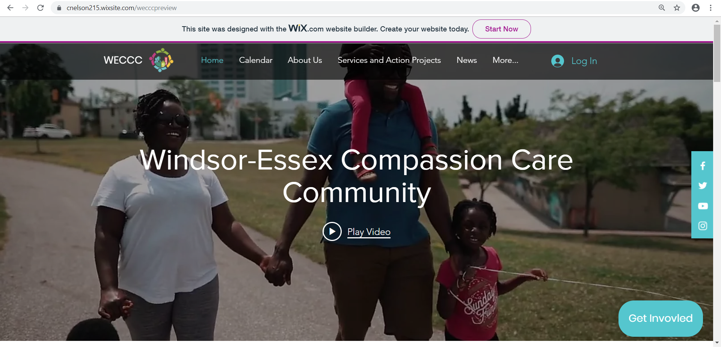
The following are pages from the new website found at www.weccc.ca :

