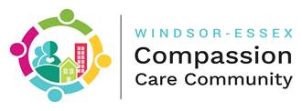

**WECCC 2019 Report to the Community**

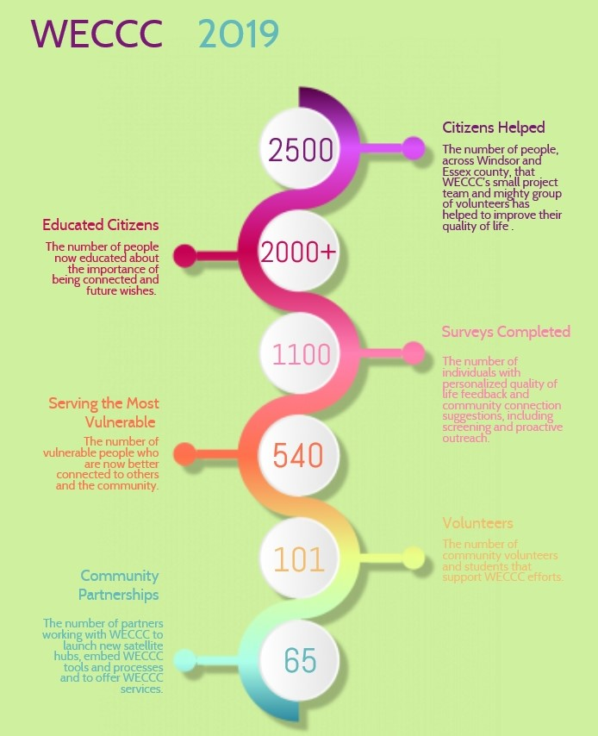

The Windsor Essex Compassion Community (WECCC) is a community system to improve population health, wellness and quality of life through prevention, screening, intervention, community development, volunteerism, and feedback. WECCC:

1. **Educates** the public on the importance of being connected
2. **Screens** people to identify social risks to health and to prompt early action
3. **Intervenes** to improve the lives of high risk or vulnerable individuals and families by providing 1:1 **connection support** to help them achieve their goals
4. Engages the whole of community in **opening doors** and **developing new opportunities** to address the aspirations and needs of groups of individuals
5. Recruits and **trains** community volunteers, students and partner organizations.
6. Provides **feedback** at multiple levels, measures progress, and reports real-time impacts on population health and quality of life

WECCC benefits people who are isolated or vulnerable, caregivers, and the general public. WECCC is delivered by a dedicated project team of just under 5 FTEs, supported by trained volunteers and students, and a wide range of community partnerships.

**The Human Impact of WECCC**

WECCC is saving lives

* Several WECCC members feel severe anxiety, depression and suicidal ideation. In 2019, our volunteers encountered 7 individuals with an expressed wish to die and a specific plan, and were able to intervene quickly to connect people with emergency support. Volunteers stick around to help rebuild lives afterwards.

WECCC is getting lives back on track

* A man who was isolated inside his house for 9 years because he couldn’t manage his stairs now has a ramp and a new wheelchair and can go outside
* A man in his early 60s lost his job while being a caregiver for his wife with a recent brain injury and a 37 yr. old son in Hospice for end of life care. WECCC connected them with housing support so they did not become homeless, assisted him with a grant to support families who have a child with cancer, and found a volunteer who repaired his car for free and put it back on the road.
* A man living in an abusive relationship now has resources to live on his own – including OW, ODSP, passport funding, resources for food banks and cat food, and free dental work.

WECCC is helping people who are vulnerable achieve basic dignity

* A woman who did not get out of bed, even to use the bathroom, and cannot afford to buy her own supplies now receives weekly donations of pads and diapers, has extra home care support, and has phone call support from another isolated lonely member every morning at 10:00 am
* A 37 year old woman who was asked to leave several programs because of body odour has received medical assistance addressing her problem and is now much happier and healthier.

WECCC is bringing people and families together

* A woman who is homebound and friendless is now able to connect via computer with her son who lives in China. After three years of no contact, she will have her son home for Christmas.
* A woman who was homebound and without care now has a personal support worker and regular visits through a local friendly visitor program. These interactions encouraged her to reach out to her own neighbours whom she now visits with a few times each week. Her new connections with those around her allowed her to watch her granddaughters wedding from the safety of her own home.

WECCC offers comfort and support at end of life

* With a donated scooter SMJ found her, an elderly woman who was isolated is now able to go out looking at gardens and talk to her neighbours. She has worked through her wishes and plans with her family, and now feels comfortable with her end of life decisions

**How WECCC Works**

**Tested Programs and Activities: The WECCC Dozen**

WECCC has developed and is delivering a wide range of programs and activities communities can use to improve population health and quality of life.

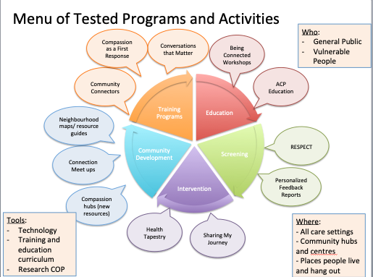

**Filling in the Gaps with Practical Help-** *What kind of connections can WECCC help make?*

Virtually anything that will achieve a person’s goals and improve their life. We have helped people find activities they love to do, reach out to meet other people, learn to ride a bus, get their paperwork sorted out, find jobs, housing, furniture and places to get food, develop their own plans for self-care, build a ramp to get outside, get their car fixed, find opportunities to use their time and talents to help others, and many more things. We have helped people actively thinking about suicide get help.

**Working with Community Partners to Create New Opportunities**

WECCC/SMJ members have identified the following 6 community challenge areas we will be prioritizing in 2020 in order to create new opportunities to meet the needs of the community:

* Better emotional and mental health support; more support groups
* More social visits (including creating meaningful opportunities for virtual connections between people with reduced mobility)
* Better pain management, especially alternative therapies
* More informal transportation options that are flexible and low cost
* Community connection tables at community meals to build trust and practical support for people who are disenfranchised
* Inclusion and diversity, including expansion to additional populations such as LBGTQ2, corrections, patient support and disease management groups, at risk youth, and more newcomer, cultural and faith communities

**2019 Participation Highlights**

In 2019, the WECCC team helped improve the quality of life of over 2500 citizens through the following direct services:

Prevention (educating and informing over 2,000 people)

* Educated 1016 individuals on the importance of being connected
* Educated 1053 individuals on advance care planning

Screening (giving feedback to 1,200 people and helping identify those at high risk)

*Screening is provided as part of both education and intervention services*

* Provided over 1,094 individuals with personalized quality of life feedback and community connection suggestions, including screening and proactive outreach
* Helped 94 individuals self-rate their mortality risk (RESPECT), to improve awareness and access to palliative and/or holistic care

Intervention (helping 540 seniors and at risk individuals, and their families)

* Worked with 16 organizations to identify individuals falling through the cracks through our Compassion is a First Response network
* Intervened to help 222 high risk individuals connect with others and community resources to reduce disconnection and improve quality of life
* 321 members who joined SMJ previously continue to receive regular check-in support.

Volunteer Training

* Trained, supervised and mentored 101 new community volunteers. Our community volunteer team has grown to 41 regular volunteers, plus 38 local volunteers engaged through community hub partners. WECCC PMO also supervised 22 student placements
* Trained a wide range of community partners to use WECCC processes and tools within their own programs, through a train the leader approach.

Community Development

* Worked with local champions in 4 new geographies to spread Compassion hubs more widely throughout Windsor and Essex county
* Partnered with 65 community organizations who are directly supporting the WECCC movement at a number of different levels
* Hosted neighbourhood connections, events and meet-ups to encourage new connections and promote informal exchanges of time and talent between community members
* Supported a variety of communications events and channels to grow public awareness.

*We are working on a system to track and measure the impact of our community development and capacity-building work.*

**RESULTS**

WECCC is demonstrating that it can deliver meaningful results for citizens and communities. A growing body of both quantitative and qualitative evidence demonstrates each component of WECCC has potential for impact at multiple levels.

**Social Impact**

Education: Loneliness

1016 individuals participated in 133 WECCC community education workshops to learn about the importance of being connected and received personalized information about community resources to help them stay connected

* 95% of participants gained new knowledge and skills
* 87% of participants rated the information as relevant to their needs
* 6 months following the education, 73% of people contacted indicated that they used this knowledge to reach out and help others and/or to make progress in achieving their own person-directed goals

Education: Advance Care Planning

1053 individuals participated in 58 community education workshops and 52 1:1 sessions to learn about communicating future wishes and health care consent and capacity. 193 ACP/POA plans were completed

* Overall rating for the sessions was 97% based on criteria of usefulness, relevance, organization, presentation, visual aids, and instruction
* 97% of participants rated the information as relevant to their needs

Feedback: Personalized Reports

* 1,094 individuals registered with WECCC and received personalized reports with quality of life feedback and community connections suggestions – individuals participated through education workshops, We Care Let’s Talk community events, volunteer training and through the Sharing My Journey intervention
* Each report is **screened** by WECCC for quality of life alerts, and proactive outreach offered if triggered (about 5-10% of community reports)
* Since we began in 2017, WECCC has prepared personalized reports with feedback and community connections suggestions over 2,300 individuals

Intervention: Sharing My Journey

SMJ is demonstrating it can deliver excellent member experience with high potential for effectiveness and impact. 222 new members on average made over 7 new connections with other people and a wide variety of community resources to advance quality of life goals. Program evaluation evidence (based on 50 completed surveys) demonstrates:

* Experience: 96% were satisfied with their overall experience and quality of support; 98% would recommend SMJ to a family member or friend
* Improved health and wellness: Most participants reported significant improvements. 88% believe that, because of this program, their life is better than before; 94% reported decreased loneliness and/or isolation; 88% reported increased well-being and/or life satisfaction; 75% identified less anxiety/ depression; 50% identified less pain
* Improved self-management: 88% feel they are making progress in meeting their goals; 89% feel they are aware and better able to deal with challenges; 95% feel better supported by the community, friends and family; 91% feel confident they are getting the help they need; 93% have confidence in plans for future care

Approximately 320 members from previous years continue to receive check-in support.

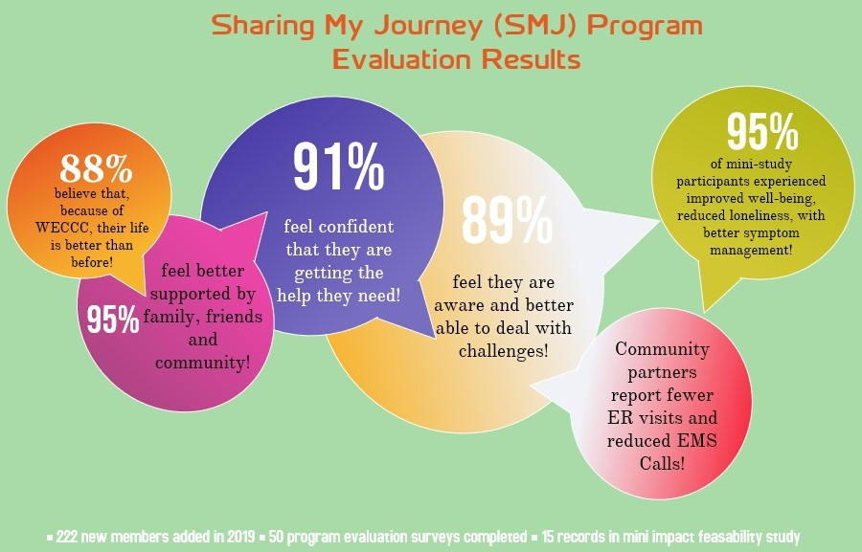

The WECCC research team completed a mini feasibility study to examine the potential of SMJ for effectiveness and impact on vulnerable groups. Key findings included:

1. SMJ is a highly flexible intervention suitable for a wide range of individuals and settings.
2. Participants in SMJ have multiple characteristics of vulnerability including: poverty, low income, or recent homelessness; serious illness; poor self-rated health and serious functional limitations; being elderly (80+) and living alone. A significant number of participants report being victims of trauma or abuse
3. Participants in SMJ are seriously disconnected. Quality of life self-assessment at baseline showed that individuals received on average 7.5 of 10 alerts[1] for disconnection including low self-rated health or mental health; low life satisfaction or personal well-being; loneliness; isolation; perceived lack of support; infrequent participation in community activities.
4. Participants in SMJ are able to identify multiple goals and plans to improve their quality of life and wellness.
5. SMJ is able to identify multiple resources – primarily community and social - to help individuals make progress on individual goals, reduce unmet needs, and help others.
6. SMJ is able to demonstrate effectiveness and impact. 100% of mini-study participants (n=15) reported at least one area of improvement/reduced disconnection at graduation compared to baseline. On average, each participant showed improvement in over **6 risk areas** compared to baseline.
7. SMJ compliments without duplicating other health care and community services.

**Economic impact**

**WECCC is helping prevent waste of system resources**

* Provider partners have indicated that because of WECCC, patients in their care have reduced EMS calls and ER visits for social reasons; and enabled people to receive care in the community where they want to be, delaying or avoiding admission to more expensive health care institutions.

**University of Windsor Program Evaluation – Key Findings** *(Manuscript in process)*

The experience of vulnerability includes: being ‘invisible’, brittle support system, social isolation, complex health and life issues. The WECCC intervention is achieving a significant impact in the community. 5 key themes emerge from qualitative research:

1. **The little things are big**

*“I can’t really explain how important that was to be considered a human being” (client)*

*“…it was the little things, like she [the client] wasn’t able to wash her hair and her daughter was burning out and didn’t have contact in the community.” (LHIN care coordinator 1)*

1. **A new set of eyes**

*“It’s just like a new set of eyes going in...I brought one of the interns in with me...they spent a couple of hours and found out that...her son was a student and working full-time. Even though she [the client] told me he was coming to bring her food, he didn’t.” (LHIN care coordinator 2)*

*“Like we have individuals who...were a victim of elderly abuse and sometimes people don’t get to see the positives of their life...They cannot take a step back and see.” (LHIN care coordinator 3)*

1. **Taking time to figure it out**

*“I think people get overwhelmed with…maybe its medical jargon or it’s just they don’t want to be taking up somebody’s time; they don’t think it’s a big enough deal but us being able to say, ‘no you should call for that’ or if they don’t want to call, ‘we will call for you and we’ll figure it out’.” (nursing student)*

1. **Return on Investment**

*“I know the helplessness you feel when you’re homeless and you know I’m not in that ratio [right now], but even so, it’s like you know when I’m homeless it’s like I don’t even know if anyone else cares … Right now I’m at the point where I want to help-people to get out of it.” (client)*

*“I had a patient who was in chronic pain and…didn’t have a family doctor, she didn’t have any management of her pain…she couldn’t function…she was so socially isolated…We…got her signed up with Health Care Connect, we got her a family doctor. We had VON connect with her to help with pain management and we also signed her up with Hospice…so that when she had that pain managed then we can work around the social isolation.” (nursing student)*

1. **Opportunities**

Improving community services (transportation, mental health supports, housing), volunteers, specialized training for volunteers, documentation and data sharing

**WECCC IS PROVIDING VALUE FOR MONEY**

**The WECCC Team**

WECCC’s project staff is comprised of 4.4 FTEs:

* Educator: Being Connected (.6 FTE Part-time)
* Educator: Advance Care Planning (.4 FTE Part-time)
* Sharing My Journey Coordinators (2 FTEs)
* Information, resources and research support (1 FTE)
* Communications (.4 FTE);
* Project leadership and applied research (in-kind donation of time and expertise);
* Organizational support through hospice (including program management, HR, payroll, IT, housekeeping and office maintenance, etc).
* In addition, Assumption Cares has hired its own Coordinator for its hub.

**Total Funding 2019**

$250,000 OTF

$100,000 ESC LHIN

$350,000 TOTAL

*NOTE: WECCC also participates in a provincial Health Tapestry research project, and is separately funded for 1 FTE Health Tapestry Volunteer Coordinator. The Health Tapestry RCT concludes in spring 2020.*

**Cost of Delivery**

WECCC offers delivers broad public health education and support to highly vulnerable people falling through the cracks of traditional care systems for relatively low cost. In terms of value of money, we have estimated the direct costs currently being expended to deliver each of the separate arms of WECCC as follows:

Prevention (educating and informing over 2,000 people about the importance of being connected and advance care planning)

* Estimated at 20% of project budget/staff resources
* Cost to project per person educated = $35

Screening (giving feedback to 1,200 people and helping identify those at high risk)

* Estimated at 15% of project budget/ staff resources
* Cost to project per feedback report generated = $43 *(NOTE: we will be introducing a new survey platform in 2020 which will significantly reduce this cost)*

Intervention (helping 540 seniors and at risk individuals, and their families)

* Estimated at 50% of project budget/ staff resources
* Cost to project per SMJ member served = $324

Training (trained 101 new community volunteers and 65 community partners)

* Estimated at 15% of project budget/ staff resources
* Cost to project per volunteer/community partner trained = $316

*NOTE: these costs are currently reflective ONLY of the direct operational costs of the WECCC team over and above existing funded community resources and assets. We acknowledge that partner agencies and volunteers also contribute in-kind time and effort, which may affect the availability of time and efforts they could be spending on other activities. We also acknowledge that full costs of project management/ operational oversight, technology, communications, data management, research and evaluation are not captured in the estimates above but would be required in order to spread this program more broadly.*

**MOMENTUM AND SPREAD**

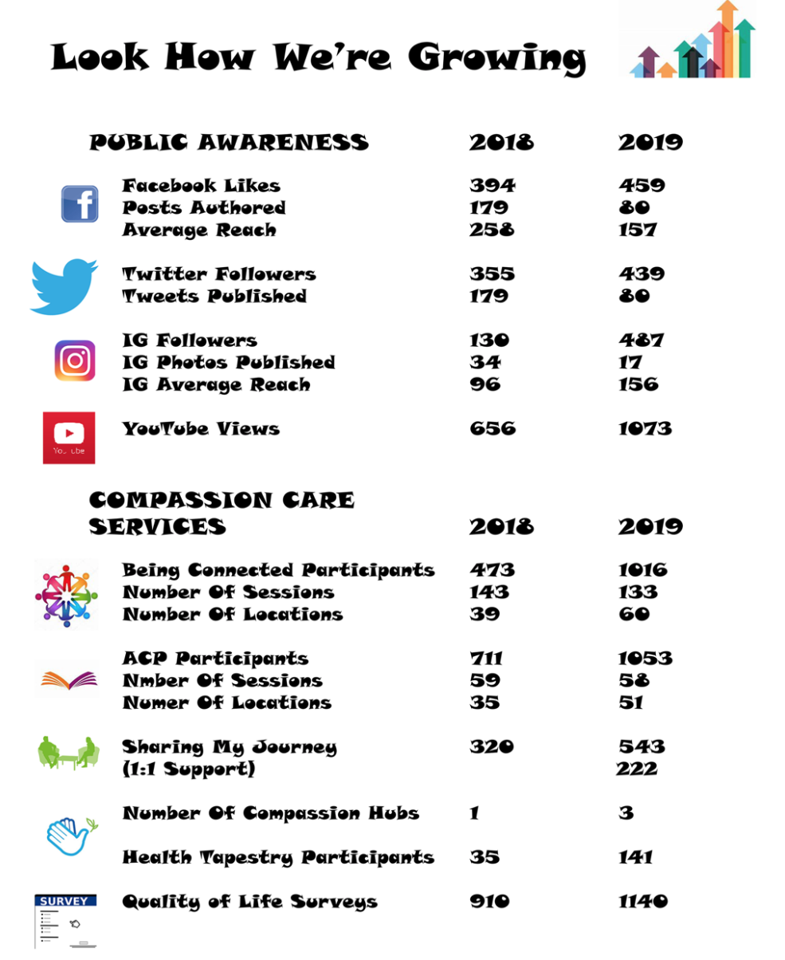

To grow both a robust and sustainable movement, in 2020 we will be focusing on the following growth strategies:

* Train the trainer resources for spread of WECCC education
* Satellite hubs for growth and greater accessibility
* Embedding tools and volunteer teams in host agencies for sustainability
* Formal program evaluation
* 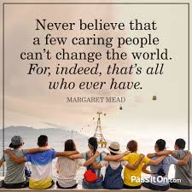Measuring more time interval change and change in outcomes

1. Alerts are generated through the WECCC survey system when an individual’s results are below the normative average for each item/ scale. Normative averages are evidence-based. Each of these identified factors is independently linked to significantly increased risk of disease, health decline, high health care costs, and/or early mortality.